**THE PUBLIC SECTOR PROFILE OF THE**

**PAN-CANADIAN TRUST FRAMEWORK (PCTF)**

**VERSION 1.1**

|  |  |
| --- | --- |
| Document Version: | 0.3 |
| Document Status: | Consultation Draft |
| Date: | 2020-02-20 |
| Security Classification: | UNCLASSIFIED |

Document Version Control

|  |  |  |  |
| --- | --- | --- | --- |
| **Version**  **Number** | **Date of Issue** | **Author(s)** | **Brief Description** |
| 0.1 | 2019-10-10 | PSP PCTF WG | Consultation Draft |
| 0.2 | 2019-10-31 | PSP PCTF WG | Consultation Draft |
| 0.3 | 2020-02-20 | PSP PCTF WG | Consultation Draft |

Table of Contents

Document Version Control iii

Table of Contents v

List of Figures vii

Executive Summary ix

1 Introduction 1

2 The Pan-Canadian Trust Framework 3

2.1 Overview 3

2.1.1 Background 3

2.1.2 What is the PCTF? 3

2.1.3 Scope of the PCTF 4

2.2 The PCTF Model 5

2.3 Normative Core 7

2.3.1 Identity Domains 7

2.3.2 Digital Representations 7

2.3.3 PCTF Processes 8

2.3.4 Dependencies 8

2.3.5 Conformance Criteria 9

2.3.6 Qualifiers 9

2.4 Digital Ecosystem Roles 11

2.5 Supporting Infrastructure 15

2.6 Mutual Recognition 17

2.6.1 Mutual Recognition in the Canadian and International Context 17

2.6.2 Planning and Engagement 17

2.6.3 Process Mapping 18

2.6.4 Alignment to Other Frameworks 20

2.6.5 Assessment 20

2.6.6 Acceptance 21

2.7 PCTF Processes in Detail 23

2.7.1 Atomic Processes 23

2.7.2 Compound Processes 24

2.7.3 Conveyance of Process Output States 25

2.8 Atomic Processes in Detail 27

2.8.1 Identity Resolution 27

2.8.2 Identity Establishment 27

2.8.3 Identity Information Validation 27

2.8.4 Identity Verification 28

2.8.5 Identity Evidence Determination 28

2.8.6 Identity Evidence Validation 28

2.8.7 Identity Presentation 29

2.8.8 Identity Maintenance 29

2.8.9 Identity Linking 29

2.8.10 Credential Issuance 30

2.8.11 Identity-Credential Binding 30

2.8.12 Credential-Authenticator Binding 30

2.8.13 Credential Verification 31

2.8.14 Credential Suspension 31

2.8.15 Credential Recovery 31

2.8.16 Credential Revocation 31

2.8.17 Notice Formulation 32

2.8.18 Consent Request 32

2.8.19 Consent Registration 32

2.8.20 Consent Review 33

2.8.21 Consent Renewal 33

2.8.22 Consent Expiration 33

2.8.23 Consent Revocation 33

2.8.24 Signature Creation 34

2.8.25 Signature Checking 34

2.9 Qualifiers in Detail 35

2.9.1 Identity Domain Qualifiers 35

2.9.2 Pan-Canadian Levels of Assurance (LOA) Qualifiers 35

2.9.3 eIDAS Qualifiers 35

2.9.4 NIST Special Publication 800 63-3 Qualifiers 36

2.9.5 Secure Electronic Signature Qualifiers 36

3 Appendix A: Terms and Definitions 37

4 Appendix B: Identity Management Overview 51

4.1 Identity 51

4.1.1 Real-World Identity 51

4.1.2 Identity in Identity Management 51

4.2 Defining the Population 51

4.3 Defining the Identity Context 52

4.4 Determining Identity Information Requirements 53

4.4.1 Identifier 54

4.4.2 Assigned Identifier 55

4.5 Identity Resolution 56

4.6 Ensuring the Accuracy of Identity Information 56

5 Appendix C: Persons and Organizations 59

5.1 Legal Entities 59

5.2 Juridical Persons 59

5.3 History of Juridical Persons 60

5.4 Examples of Juridical Persons 61

5.5 Legal Entity Information 62

6 Appendix D: Identity and Credential Verification 63

6.1 Identity Verification 63

6.2 Credential Verification 64

7 Appendix E: Bibliography 65

8 Appendix F: Thematic Issues 67

List of Figures

Figure 1: The Pan-Canadian Trust Framework Model 5

Figure 2: Digital Ecosystem Roles and Information Flows 11

Figure 3: Supporting Infrastructure 15

Figure 4: Atomic Process Model 23

Figure 5: Examples of Atomic Processes (Modeled) 24

Figure 6: Identity Confirmation Compound Process 25

Figure 7: Conveying Output States between Parties 26

Executive Summary

This document describes **Version 1.1** of the public sector profile of the ***Pan-Canadian Trust Framework (PCTF)***. The document is structured as follows:

* **Section 1** describes the purpose, stakeholders, and audience of the document
* **Section 2** describes the main elements of the PCTF
* **Sections 3 through 8** provide various appendices that cover terms and definitions, discussions on selected topics related to the PCTF, a bibliography, and a list of issues that will be resolved in future versions of the document.

The Pan-Canadian Trust Framework will facilitate the transition to a digital ecosystem for citizens and residents of Canada. A Canadian digital ecosystem will increase efficiency and secure interoperability between existing business processes, such as open banking, business licencing, and public sector service delivery.

The PCTF is simple and integrative; technology-agnostic; complementary to existing frameworks; clearly linked to policy, regulation, and legislation; and is designed to apply relevant standards to key processes and capabilities.

The PCTF facilitates a common approach between all levels of government and the private sector thereby serving the needs of the various communities who need to trust digital identities. The PCTF is defined in a way that encourages innovation and the evolution of the digital ecosystem. The PCTF allows for the interoperability of different platforms, services, architectures, and technologies.

The PCTF defines two types of *digital representations* that are essential for the development of the digital ecosystem:

1. *Digital identities* of persons and organizations, and
2. *Digital relationships* between persons, between organizations, and between persons and organizations.

The PCTF supports the acceptance of digital identities and digital relationships by defining a set of discrete process patterns, known as *atomic processes*. These atomic processes can be mapped to existing business processes, independently assessed using conformance criteria, and certified to be trusted and interoperable within the digital ecosystem.

# Introduction

The purpose of this document is to describe the public sector profile of the Pan-Canadian Trust Framework (PCTF)[1].

The stakeholders of the PCTF consist of:

* Persons and organizations acting in their own interest
* The public sector
* Non-governmental organizations
* The private sector

The audience for this document includes:

* Members of the digital ecosystem from the public and private sectors (including regulatory and standards bodies) – as key stakeholders and contributors to the PCTF;
* Digital identity technology and service providers – to understand where they fit in the PCTF, to help define requirements for their products and services, and to assess the integrity of their processes; and
* Digital identity consumers and program/service providers – to assess the value of employing digital identity solutions and processes when interacting online.

Definitions of various terms used in this document can be found in *Appendix A: Terms and Definitions*.

# The Pan-Canadian Trust Framework

## Overview

### Background

The nature of the Canadian federal polity has produced an identity management ecosystem comprised of multiple identity providers relying on authoritative source registries that span provincial/territorial and federal jurisdictions. Consequently, the Canadian ecosystem employs a federated identity model.

The Pan-Canadian Trust Framework (PCTF) is an outcome of the Pan-Canadian approach for federating identities which is an agreement on the principles and standards to be used when developing identity solutions.[2] This approach, embodied in the PCTF, is intended to facilitate the transition to a digital ecosystem which will enable transformative digital service delivery solutions for citizens and residents of Canada.

### What is the PCTF?

The PCTF is a model that consists of a set of agreed-on concepts, definitions, processes, conformance criteria, and an assessment approach. It is not a “standard” as such, but is, instead, a framework that relates and applies existing standards, policies, guidelines, and practices, and where such standards and policies do not exist, specifies additional criteria. The role of the PCTF is to complement existing standards and policies such as those concerned with security, privacy, and service delivery.

The PCTF facilitates a common approach between the public sector and the private sector. Use of the PCTF ensures alignment, interoperability, and confidence of digital identity solutions that are intended to work across organizational, sectoral, and jurisdictional boundaries. In addition, the PCTF demonstrates a clear linkage to legislation and policies and thereby ensures ongoing legal and policy compliance.

The PCTF supports the acceptance and mutual recognition of:

* Digital identities of persons and organizations; and
* Digital relationships between persons, between organizations, and between persons and organizations.

The PCTF defines a set of discrete process patterns (called atomic processes) that can be mapped to business processes. This mapping makes possible a structured assessment and evaluation of a digital identity solution and identifies any dependencies on external organizations and providers.

The PCTF is technology-agnostic and is defined in a way that encourages innovation and participation in the digital ecosystem. It allows for the interoperability of different platforms, services, architectures, and technologies. Furthermore, the PCTF is designed to leverage international digital identity frameworks, such as:

* The Electronic Identification, Authentication, and Trust Services (eIDAS);
* The Financial Action Task Force (FATF); and
* The United Nations Commission on International Trade Law (UNCITRAL).

Finally, it should be noted that the PCTF, in itself, is not a governance framework. Instead, it is a tool to help assess a digital identity program that puts into effect the relevant legislation, policy, regulation, and agreements between parties.

### Scope of the PCTF

The scope of the Pan-Canadian Trust Framework is:

* Persons in Canada, which is defined as all citizens and residents of Canada (including deceased persons) for whom an identity has been established in Canada;
* Organizations in Canada, which is defined as all organizations registered in Canada (including inactive organizations) for which an identity has been established in Canada; and
* Relationships in Canada of persons to persons, organizations to organizations, and persons to organizations.

## The PCTF Model

The PCTF model is illustrated in Figure 1.

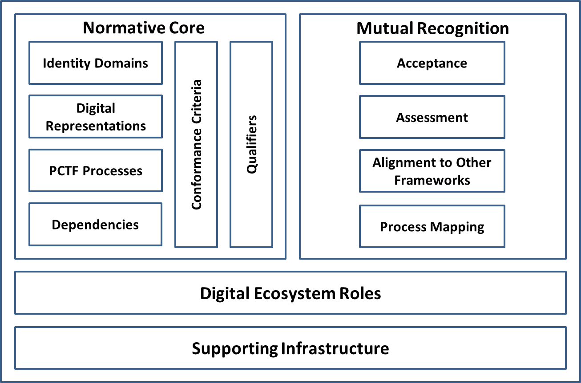

Figure 1: The Pan-Canadian Trust Framework Model

The PCTF model consists of 4 components:

1. A **Normative Core** component that encapsulates the key concepts of the PCTF;
2. A **Digital Ecosystem Roles** component that defines the roles and information flows within the digital ecosystem;
3. A **Supporting Infrastructure** component that describes the set of technical, operational, and policy enablers that serve as the underlying infrastructure of the PCTF; and
4. A **Mutual Recognition** component that outlines the methodology that is used to assess and certify actors in the digital ecosystem.

These components are discussed in more detail in the Sections that follow.

## Normative Core

### Identity Domains

The PCTF draws a clear distinction between *foundational identity* and *contextual identity*.

* A **Foundational Identity** is an identity that has been established or changed as a result of a foundational event (e.g., birth, person legal name change, immigration, legal residency, naturalized citizenship, death, organization legal name registration, organization legal name change, or bankruptcy).
* A **Contextual Identity** is an identity that is used for a specific purpose within a specific identity context[3] (e.g., banking, health services, drivers licensing, or social media). Depending on the identity context, a contextual identity may or may not be tied to a foundational identity.

The establishment and maintenance of foundational identities is the exclusive domain of the public sector; specifically:

* The Vital Statistics Organizations (VSOs) of the Provinces and Territories;
* The Business Registries of the Provinces and Territories;
* Immigration, Refugees, and Citizenship Canada (IRCC); and
* The Federal Corporate Registry of Corporations Canada;

The establishment and maintenance of contextual identities is the domain of both the public and private sectors.

### Digital Representations

A digital representation is an electronic representation of any entity that can be subject to legislation, policy, or regulations within a context and which may have certain rights, duties, and obligations; or an electronic representation of the relationship between such entities. Digital representations are intended to model real-world actors, such as persons and organizations.

Currently, the PCTF recognizes two types of digital representations:

* **Digital Identity**: An electronic representation of a person or organization, used exclusively by that same person or organization, to access valued services and to carry out transactions with trust and confidence.
* **Digital Relationship**: An electronic representation of the relationship of one person to another person, one organization to another organization, or a person to an organization.

A digital representation is the final output of a set of PCTF processes (see next Section) and therefore can be conceptualized as a set of state transitions (see Section 2.7.2).

As the PCTF evolves these digital representations will be extended to include other entity types such as devices, digital assets, and smart contracts. It is also anticipated that in the future the PCTF will be used to facilitate the mutual recognition of digital representations between countries.

### PCTF Processes

The PCTF defines a set of atomic processes that can be separately assessed and certified to interoperate with one another in a digital ecosystem. An atomic process is a set of logically related activities that results in a state transition[4]. The PCTF recognizes that in practice a business process is often a collection of atomic processes that results in a set of state transitions. Theses collections of atomic processes are referred to as compound processes. See Section 2.7 for more information on the PCTF processes.

All of the atomic processes have been defined in a way that they can be implemented as modular services and be separately assessed for certification. Additional atomic processes can be added as required and all of the atomic processes can be mapped to various conformance criteria qualifiers.

Once an atomic process has been certified, it can be relied on or “trusted” and integrated into other digital ecosystem platforms. This digital ecosystem is intended to interoperate seamlessly across different organizations, sectors, and jurisdictions, and to be interoperable with other trust frameworks.

### Dependencies

The PCTF model recognizes two types of dependencies. The first type are those dependencies that exist between atomic processes. Although each atomic process is functionally discrete, to produce an acceptable output an atomic process may require the successful prior execution of another atomic process. For example, although *Identity Establishment* of a person or organization can be performed independently at any time, it is logically correct to do so only after *Identity Resolution* for that person or organization has been achieved. This type of dependency is specified in the conformance criteria (see next Section).

The second type are dependencies on external organizations for the provision of atomic process outputs. This type of dependency is identified and noted in the assessment process (see Section 2.6.5).

### Conformance Criteria

Conformance criteria are a set of requirement statements that define what is necessary to ensure the integrity of an atomic process. Conformance criteria are used to support an impartial, transparent, and evidence-based assessment and certification process.

For example, the identity resolution atomic process may involve assigning an identifier to a person or organization. The conformance criteria specify that the atomic process must ensure that the identifier that is assigned to the person or organization is unique for a specific population or context.

### Qualifiers

Qualifiers may be applied to conformance criteria. Qualifiers help to further indicate a level of confidence, stringency required, or a specific requirement, in relation to another trust framework, an identity domain requirement, or a specific policy or regulatory requirement. Qualifiers can be used to select the applicable conformance criteria to be used in an assessment process. Qualifiers can also be used to facilitate mapping conformance criteria equivalencies across different trust frameworks.

Conformance criteria may have no qualifiers (applicable in all cases), a single qualifier (applicable in certain cases), or several qualifiers (applicable in many cases). See Section 2.9 for more information on qualifiers.

## Digital Ecosystem Roles

Figure 2 illustrates a conceptual model of the digital ecosystem roles and information flows.

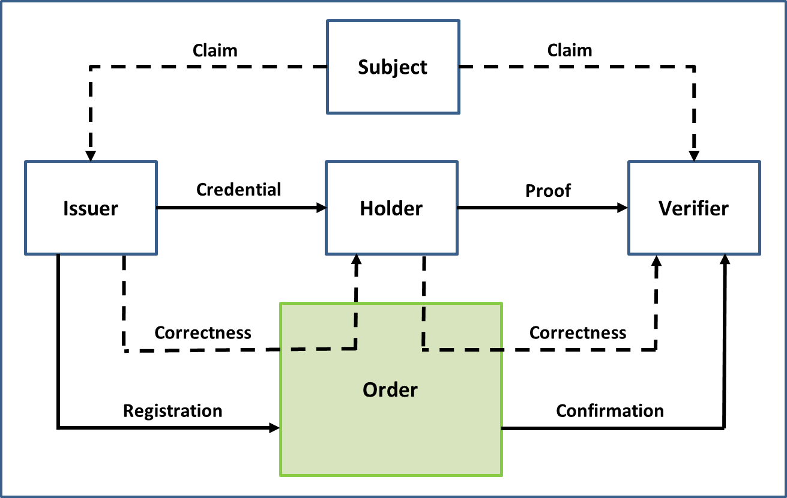

Figure 2: Digital Ecosystem Roles and Information Flows

The model consists of 5 roles:

1. **Subject:** An entity about which ***Claims*** are made. (It should be noted that a *digital representation* is an electronic representation of a Subject.)
2. **Issuer:** An entity that asserts ***Claims*** about one or more ***Subjects***, creates a ***Credential*** from these Claims, and transmits the Credential to a ***Holder***.
3. **Holder:** An entity that controls a ***Credential*** from which a ***Proof*** can be generated and presented to a ***Verifier***. A Holder is usually, but not always, the ***Subject*** of a Credential.
4. **Verifier**:An entity that consumes ***Proofs*** of ***Claims*** for the purposes of delivering services or administering programs. A Verifier accepts a Proof from a ***Holder***.
5. **Order:** A generalized representation of various sets of rules and the entities that employ or administer those rules. The term “order” draws on the *private ordering*[5] concept established in commercial law. Order could be embodied by a data model and related schemas, a communications protocol, a blockchain, a centrally-administered database, or a combination of these and similar sets of rules.

The model makes no assumption on any asymmetric power relationship between parties. Anyone can be **subjects**, **issuers**, **holders**, and **verifiers**,operating under many different **orders**.

The model also consists of 6 information flows:

1. **Claim:** An assertion made about a ***Subject***.
2. **Credential:** A set of one or more ***Claims*** made by an ***Issuer***. The Claims in the Credential can be about more than one ***Subject***.
3. **Proof:** Information derived from one or more ***Credentials***, issued by one or more ***Issuers*** that is shared with a specific ***Verifier***.
4. **Correctness:** An assurance that a ***Credential*** or ***Proof*** conforms to a particular ***Order***.
5. **Registration:** A record created by an ***Issuer***.
6. **Confirmation:** A record confirmed by a ***Verifier***.

The digital ecosystem roles are carried out by many different entities who perform specific roles under a variety of labels. These specific roles can be categorized into the digital ecosystem roles as shown in the following table.

| **Role** | **Examples** |
| --- | --- |
| **Issuer** | Authoritative Party, Identity Assurance Provider, Identity Proofing Service Provider, Identity Provider, Credential Assurance Provider, Credential Provider, Authenticator Provider, Credential Service Provider, Digital Identity Provider, Delegated Service Provider |
| **Subject** | Person, Organization, Device |
| **Holder** | Digital Identity Owner |
| **Verifier** | Relying Party, Authentication Service Provider, Digital Identity Consumer, Delegated Service Provider |
| **Order** | Infrastructure Provider, Network Operator |

Given the variety of business, service, and technology models that exist within the digital ecosystem, roles may be performed by multiple different actors in a given context, or one actor may perform several roles (e.g., be a relying party as well as a credential provider).

## Supporting Infrastructure

The Supporting Infrastructure is the set of technical, operational, and policy enablers that serve as the underlying infrastructure of the Pan-Canadian Trust Framework.

While these enablers are crucial to the PCTF, they are situated in the Supporting Infrastructure because they already have established tools and processes associated with them (e.g., Privacy Impact Assessment, Security Assessment and Authorization). The goal of the PCTF is to leverage as many of these tools and processes as possible, while maintaining a focused set of PCTF-specific atomic processes and conformance criteria. Figure 3 illustrates the Supporting Infrastructure.

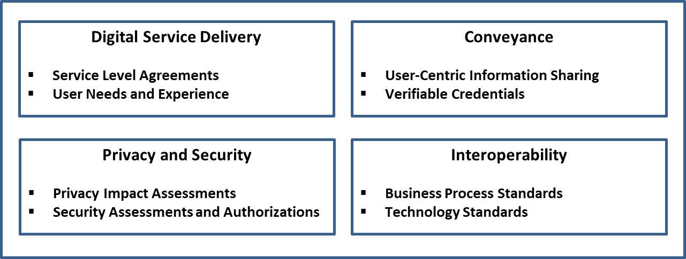

Figure 3: Supporting Infrastructure

## Mutual Recognition

### Mutual Recognition in the Canadian and International Context

Mutual recognition is an agreement by which two or more jurisdictions (or sectors) agree to recognize one another's conformance assessment results. Depending on the context, the mutual recognition may be formalized through the issuance of a letter of acceptance or be part of larger arrangement or agreement.

At this time, the mutual recognition process is still in its early stages. The following Sections outline mutual recognition at a high level. Detailed guidance will follow in subsequent deliverables.

### Planning and Engagement

Prior to commencing the PCTF mutual recognition process, it is recommended that there be a planning and engagement process with the key participants to develop a formalized work arrangement. This process has the following steps:

* **Define the Scope of the Assessment**. The scope of the assessment may include one or more parties acting in the roles defined as part of the digital ecosystem. While the primary focus of the assessment is usually a jurisdiction as an “issuer”, the assessment may include additional parties who have been delegated specific business functions or roles. The PCTF model may also be used to clarify roles and responsibilities that are relevant to, but not necessarily within scope of the formal assessment process.
* **Formalize the Team.** Formalize the mutual recognition project team who will be responsible for the process and deliverables. The project team should consist of the assessment team and members from the participating organizations who have detailed operational knowledge of the program.
* **Site Visit.** The assessment team should perform a site visit. The desired outcome is to ensure that the assessment team members can gain direct knowledge of the program and establish close working relationships with the other mutual recognition project team members to facilitate knowledge transfer and shared understanding.
* **Define a Discrete Work Stream**. While the mutual recognition project team may be integrated into a larger project initiative, the mutual recognition process should be maintained as a discrete work stream. However, the work stream should have tight synchronization with the other work streams, such as privacy impact assessments, security assessment and authorization, and technical integration.
* **Engage Legal Counsel Early**. It is recommended that legal counsel of all parties be engaged early in the process. As the assessment process and the ensuing arrangements may be new in relation to existing arrangements, there may be implications for respective authorities and agreements.
* **Records Management**. Ensure that all evidence received, and assessment documents and working drafts are filed in a proper records management system under the appropriate security categorization. Upon completion of the assessment, all material should be finalized as records for audit purposes.

### Process Mapping

Process mapping consists of the set of activities to map program activities, business processes, and technical capabilities to the atomic processes defined in the PCTF.

In most cases, this mapping is applied to an existing program currently in operation. The following are some recommendations:

* **Define the Scope of the Mapping.** Typically the mapping will be of an established program or business line. The scope of the mapping may include upstream programs such as vital statistics or external commercial service providers. These may be included in the scope of the assessment or identified as *dependencies*.
* **Be Prepared for Terminology Variation.** Many programs under assessment will be well-established and using terminology for their context. The purpose of the mapping process is not to introduce new terminology, but rather to map what exists in name to what needs to be assessed using the PCTF. The table at the end of this Section illustrates some examples.
* **Work closely with all Team Members.** A large part of the process mapping is a discovery process by the team. While existing documentation may be the primary source of information, interviews with subject matter experts and operational personnel may be required. Workshops may also need to be held to arrive at a common understanding and mapping.
* **Clarify Responsibilities Between Parties.** Similar processes may be carried out or duplicated across the different parties. For example, “enrolment” in a digital identity program, may be the same as or different from a subsequent “enrolment” in a service that has accepted the digital identity. The mapping of the atomic processes can help to clarify what may be a duplicate (i.e., redundant) process to the user, and what may be specifically required for the service.

The table below illustrates some examples of mapping to existing business processes.

| **Atomic Process** | **Existing Business Process Examples** |
| --- | --- |
| **Identity Resolution** | A service enrolment process that attempts to uniquely identify a person based on the person’s name and date of birth  A business registry process that attempts to uniquely identify an organization based on the organization’s legal name |
| **Identity Establishment** | A birth registration process that creates an authoritative birth record  A program enrolment process that creates a user account profile  A business registry process that create an authoritative business record |
| **Identity Information Validation** | A driver’s license application process that confirms identity information as presented on physical documents or by means of an electronic validation service  A cannabis licensing process that confirms identity information as presented about a business by means of an electronic validation with the applicable business registry |
| **Identity Verification** | Asking questions of the person presenting the identity information – the answers to which (in theory, at least) only they and the interrogator would know (e.g., financial information, credit history, shared secret, mailed-out access code, password, personal identification number, assigned identifier)  A passport application process that compares biological characteristics recorded on a document (e.g., facial photograph, eye colour, height) to ensure it is the right applicant |
| **Identity Maintenance** | An identity information notification service  An identity information retrieval service |
| **Credential Issuance** | Issuing an authoritative document such as a birth certificate or driver’s licence  Issuing an authoritative document such as a certificate of existence or compliance  Issuing a verifiable credential |

### Alignment to Other Frameworks

Alignment of processes, systems, and solutions assists in mutual recognition across an international context where multiple frameworks may be in use.

For example, someone who accesses Canadian digital services, may also need to access digital services in other countries. Recognizing this evolution toward the international context, the PCTF is designed to be applied in conjunction with established and emerging global frameworks, such as:

* The Electronic Identification, Authentication, and Trust Services (eIDAS)
* The Financial Action Task Force (FATF) – *Guidance on Digital Identity*
* The United Nations Commission on International Trade Law (UNCITRAL) – *Draft Provisions on the Cross-border Recognition of Identity Management and Trust Services*

International mutual recognition is still in its early phases. Consideration should be given to aligning to these frameworks before commencing the assessment process. Currently, the Digital Nations Thematic Group on Digital Identity is commencing work on mutual recognition between countries.

### Assessment

The PCTF defines a normative set of atomic processes and accompanying conformance criteria. Once the existing business processes have been mapped to the atomic processes, they can be assessed and a determination made against each of the related atomic process conformance criteria. The current assessment determinations are:

* **Accepted** – The conformance criteria are met;
* **Accepted with Observation** – The conformance criteria are met, but a dependency or contingency over which the assessed party might not have direct control has been noted;
* **Accepted with Recommendation** – The conformance criteria are met, but a potential improvement or enhancement should be implemented in the future;
* **Accepted with Condition** – The conformance criteria are not met, but the atomic process is accepted due to the demonstration of safeguards, compensating factors, or other assurances in place;
* **Not Accepted** – The conformance criteria are not met; or
* **Not Applicable** – The conformance criteria do not apply.

The PCTF assessment process is intended to be adaptable. If necessary, certain atomic processes may be excluded from the assessment process and conformance criteria may be tailored for a specific context. However, this should be done with care as any adjustments or tailoring may impact the quality of the mutual recognition process.

A detailed worksheet has been developed to assist in the PCTF assessment process. This worksheet consolidates the atomic processes and accompanying conformance criteria into a single spreadsheet to aid in the mapping of existing business processes and assist the assessment team in cross-referencing data for assessment analysis. The conformance criteria are also mapped to qualifiers to assist in the selection of the conformance criteria that are applicable to the assessment process.

Evidence collected to support the analysis and substantiate the determination should be collected and recorded in a manner that can be easily cross-referenced to the applicable conformance criteria.

It should be noted, that by design, the PCTF does not assume that a single provider is solely responsible for all of the processes. Therefore, several bodies might be involved in the PCTF assessment process, focusing on different processes, or different aspects (e.g., security, privacy, service delivery). Consideration must be given to how to coordinate several bodies that might need to work together to yield an overall PCTF assessment.

As the PCTF assessment process evolves, consideration will be given to determine which bodies and/or standards are best suited to meet stakeholder requirements and best applied in relation to the PCTF.

Finally, legislation and regulations may change in response to the evolution of the digital ecosystem. Lessons learned from implementing solutions based on PCTF assessments may be considered as input into any potential legislative or regulatory changes.

### Acceptance

Acceptance is the process of formally approving the outcome of the assessment process. The acceptance process is dependent on the applicable governance, taking into account the respective mandates, legislation, regulations, and policies.

Currently, the PCTF is being applied under the authority of the Treasury Board Directive on Identity Management to accept digital identities issued by the Provinces and Territories. In this context, the Government of Canada is accepting digital identities from a Province or Territory for use by Federal programs and services. In turn, the Province or Territory has undergone the PCTF assessment process demonstrating conformance to the criteria specified for the applicable atomic processes.

Upon completion of the assessment process, a *Letter of Acceptance*is issued to the jurisdiction. This letter is similar in nature to a *Privacy Impact Assessment* (PIA) or an *Authority to Operate* (ATO). This letter should:

* Be addressed to the person/organization/jurisdiction accountable for being the issuer of the digital identity;
* Be signed by the person/organization/jurisdiction accepting the digital identity at a given qualifier level;
* Include the specific scope or use of the digital identity, including the time period; and,
* Include an annex listing the specific qualifiers (e.g., levels of assurance), and any observations, conditions, or recommendations arising from the assessment process.

Eventually, the PCTF acceptance process may include standard processes defined by the International Standards Organization (ISO)[6] as follows:

* **Certification**: The provision by an independent body of written assurance (a certificate) that the product, service, or system in question meets specific requirements.
* **Accreditation**: The formal recognition by an independent body (generally known as an accreditation body) that a certification body operates according to international standards.

These formalized certification and accreditation programs are currently being developed for the PCTF. It is anticipated that once formalized, independent third parties will be enabled to conduct PCTF assessments on behalf of jurisdictions. There are several domestic and international standards bodies that have recognized conformity assessment standards and programs. For example, the Standards Council of Canada, a federal Crown corporation, has the mandate to promote voluntary standardization in Canada, where standardization is not expressly provided for by law.

## PCTF Processes in Detail

### Atomic Processes

An *atomic process* is a set of logically related activities that results in the state transition of an object. The object’s output state can be relied on by other atomic processes. Figure 4 illustrates the *atomic process* model.

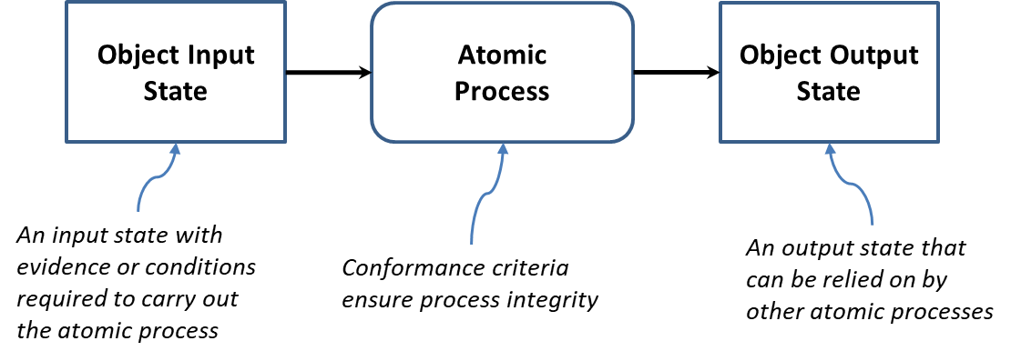

Figure 4: Atomic Process Model

Atomic processes are crucial building blocks to ensuring the overall integrity of the digital identity supply chain and therefore, the integrity of digital services. The integrity of an atomic process is paramount because the output of an atomic process is relied upon by many participants – across jurisdictional and public and private sector boundaries, and over the short term and the long term. The PCTF ensures the integrity of an atomic process through agreed upon and well-defined *conformance criteria* that support an impartial, transparent, and evidence-based assessment and certification process.

The conformance criteria associated with an atomic process specify what is required to transform an object’s input stateinto anoutput state. The conformance criteria ensure that the atomic process is carried out with integrity. For example, an atomic process may involve assigning an identifier to a person or organization. The conformance criteria may specify that any party responsible for carrying out the atomic process must ensure that the identifier assigned to the person or organization is unique for a certain population.

These atomic processes are detailed in Section 2.8.

Figure 5 illustrates some model diagrams of three atomic processes.

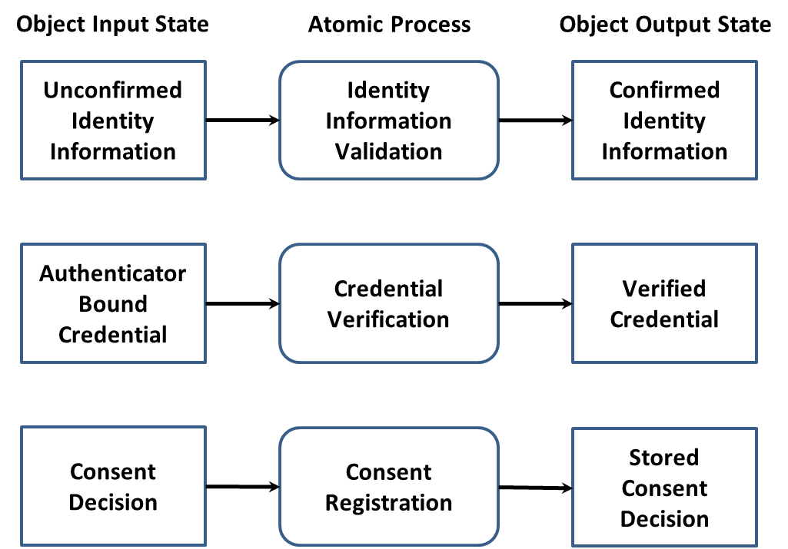

Figure 5: Examples of Atomic Processes (Modeled)

### Compound Processes

The primary function of the PCTF is to assess and certify existing business processes. When analyzed, these business processes are often composed of several atomic processes. A set of atomic processes grouped together form a *compound process* that results in a set of state transitions. It may also be the case that a compound process is composed of a set of other compound processes which in turn can be decomposed into a set of atomic processes.

For example, a business process that one party refers to as *Identity Confirmation* may in fact turn out to be a compound process consisting of 5 atomic processes as shown in Figure 6.

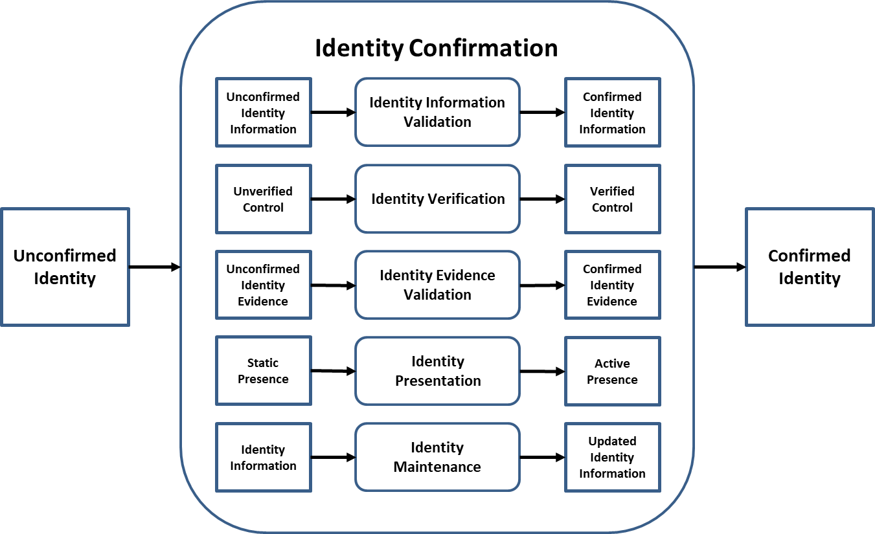

Figure 6: Identity Confirmation Compound Process

**Note**: Any ordering of the atomic processes should not be inferred from the diagram.

### Conveyance of Process Output States

The PCTF has been defined to be enabled by different platforms, architectures, and technologies all of which may co-exist with one another in the digital ecosystem. The PCTF does not constrain the possibility of several competing providers and it is anticipated that many providers will coexist to serve the needs of different communities across the public and private sector.

To facilitate the co-existence of different providers and different solution approaches, the PCTF distinguishes between the outputs that are produced and consumed by PCTF processes, and the conveyance of those outputs (i.e., how an output is carried across a network and made available to another party).

The output states can be conveyed between parties using a traditional/centralized model(e.g., a trusted third party) or a decentralized model(e.g., a distributed ledger) – or both. The output states can also be passed directly between parties. As can be seen in Figure 7, the conveyance model is situated between the parties producing and consuming the output states.

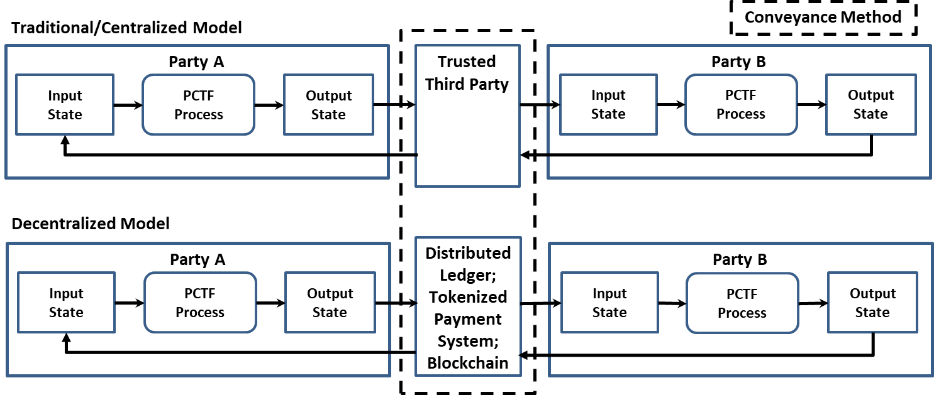

Figure 7: Conveying Output States between Parties

Requirements specific to conveyance methods are considered to be part of the Supporting Infrastructure, and will be developed as part of technical interoperability requirements, standards, and specifications.

## Atomic Processes in Detail

### Identity Resolution

|  |  |
| --- | --- |
| **Process Description** | Identity Resolution is the process of establishing the uniqueness of a Subject within a program/service population through the use of identity information. A program or service defines its identity resolution requirements in terms of identity attributes; that is, it specifies the set of identity attributes that is required to achieve identity resolution within its population. |
| **Input State** | **Non-Unique Identity Information**:The identity information is not unique to one and only one Subject |
| **Output State** | **Unique Identity Information**: The identity information is unique to one and only one Subject |

### Identity Establishment

|  |  |
| --- | --- |
| **Process Description** | Identity Establishment is the process of creating a record of identity within a program/service population that may be relied on by others for subsequent programs, services, and activities. |
| **Input State** | **No Record of Identity**: No record of identity exists |
| **Output State** | **Record of Identity**: A record of identity exists |

### Identity Information Validation

|  |  |
| --- | --- |
| **Process Description** | Identity Information Validation is the process of confirming the accuracy of identity information about a Subject as established by the Issuer. |
| **Input State** | **Unconfirmed Identity Information**:The identity information has not been confirmed with the Issuer |
| **Output State** | **Confirmed Identity Information**:The identity information has been confirmed with the Issuer |

### Identity Verification

|  |  |
| --- | --- |
| **Process Description** | Identity Verification is the process of confirming that the identity information is under the control of the Holder. It should be noted that this process may use personal information or organizational information that is not related to identity. |
| **Input State** | **Unverified Control**:The identity information has not been verified as being under the control of the Holder |
| **Output State** | **Verified Control**: The identity information has been verified as being under the control of the Holder |

### Identity Evidence Determination

|  |  |
| --- | --- |
| **Process Description** | Identity Evidence Determination is the process of determining what evidence of identity must be presented (whether physical or electronic) for Identity Information Validation or Identity Verification. |
| **Input State** | **No Identity Evidence**:No evidence of identity has been determined to be acceptable |
| **Output State** | **Accepted Identity Evidence**:The evidence of identity has been determined to be acceptable |

### Identity Evidence Validation

|  |  |
| --- | --- |
| **Process Description** | Identity Evidence Validation is the process of confirming that the evidence of identity presented (whether physical or electronic) can be admissible (i.e., beyond a reasonable doubt, balance of probabilities, and substantial likelihood). |
| **Input State** | **Unconfirmed Identity Evidence**:The evidence of identity has not been confirmed as being admissible |
| **Output State** | **Confirmed Identity Evidence**:The evidence of identity has been confirmed as being admissible |

### Identity Presentation

|  |  |
| --- | --- |
| **Process Description** | Identity Presentation is the process of dynamically confirming that the Subject has a continuous existence over time (i.e., “genuine presence”). This process can be used to ensure that there is no malicious or fraudulent activity (past or present) and to address identity spoofing concerns. |
| **Input State** | **Static Presence**: The identity exists sporadically and often only in association with a vital event or business event (e.g., birth, death, bankruptcy) |
| **Output State** | **Active Presence**: The identity exists continuously over time in association with many transactions |

### Identity Maintenance

|  |  |
| --- | --- |
| **Process Description** | Identity Maintenance is the process of ensuring that a Subject’s identity information is accurate, complete, and up-to-date. |
| **Input State** | **Identity Information**: The identity information is not up-to-date |
| **Output State** | **Updated Identity Information**: The identity information is more up-to-date |

### Identity Linking

|  |  |
| --- | --- |
| **Process Description** | Identity Linking is the process of mapping two or more identifiers to the same identity for the purpose of facilitating identity resolution. |
| **Input State** | **Unlinked Identifier**: The identifier is not associated with another identifier |
| **Output State** | **Linked Identifier**: The identifier is associated with one or more other identifiers |

### Credential Issuance

|  |  |
| --- | --- |
| **Process Description** | Credential Issuance is the process of creating and assigning a unique credential to a Holder. A credential includes one or more identifiers which may be pseudonymous, and may contain attributes verified by the Issuer. |
| **Input State** | **No Credential**: No credential exists for the Holder |
| **Output State** | **Issued Credential**: A unique credential has been assigned to the Holder |

### Identity-Credential Binding

|  |  |
| --- | --- |
| **Process Description** | Identity-Credential Binding is the process of associating the identity of a Subject with a credential issued to a Holder. |
| **Input State** | **Issued Credential**: A unique credential has been assigned to the Holder |
| **Output State** | **Identity Bound Credential**: An issued credential has been associated with the identity of a Subject |

### Credential-Authenticator Binding

|  |  |
| --- | --- |
| **Process Description** | Credential-Authenticator Binding is the process of associating a credential issued to a Holder with one or more authenticators. This process also includes life-cycle activities such as removing authenticators, binding new authenticators, and updating authenticators (e.g., changing a password, updating security questions and answers, having a new facial photo taken). |
| **Input State** | **Issued Credential**: A unique credential has been assigned to the Holder |
| **Output State** | **Authenticator Bound Credential**: An issued credential has been associated with one or more authenticators |

### Credential Verification

|  |  |
| --- | --- |
| **Process Description** | Credential Verification is the process of verifying by means of an authenticator that a Holder has control over the issued credential and that the issued credential is valid (i.e., not suspended or revoked). |
| **Input State** | **Authenticator Bound Credential**: An issued credential has been associated with one or more authenticators |
| **Output State** | **Verified Credential**: The Holder has proven control of the issued credential and the issued credential is valid |

### Credential Suspension

|  |  |
| --- | --- |
| **Process Description** | Credential Suspension is the process of transforming an issued credential into a suspended credential by flagging the issued credential as temporarily unusable. |
| **Input State** | **Issued Credential**: A unique credential has been assigned to the Holder |
| **Output State** | **Suspended Credential**: The Holder is not able to use the credential |

### Credential Recovery

|  |  |
| --- | --- |
| **Process Description** | Credential Recovery is the process of transforming a suspended credential back to a usable state (i.e., an issued credential). |
| **Input State** | **Suspended Credential**: The Holder is not able to use the credential |
| **Output State** | **Issued Credential**: A unique credential has been assigned to the Holder |

### Credential Revocation

|  |  |
| --- | --- |
| **Process Description** | Credential Revocation is the process of ensuring that an issued credential is permanently flagged as unusable. |
| **Input State** | **Issued Credential**: A unique credential has been assigned to the Holder |
| **Output State** | **Revoked Credential**: The Holder is not able to use the credential |

### Notice Formulation

|  |  |
| --- | --- |
| **Process Description** | Notice Formulation is the process of producing a notice statement that describes what personal information is being, or may be, collected; with which parties the personal information is being shared and what type of personal information is being shared; for what purposes the personal information is being collected, used, or disclosed; the risk of harm and other consequences as a result of the collection, use, or disclosure; how the personal information will be handled and protected; the time period for which the notice statement is applicable; and under whose jurisdiction or authority the notice statement is issued. |
| **Input State** | **No Notice Statement**: No notice statement exists |
| **Output State** | **Notice Statement**: A notice statement exists |

### Consent Request

|  |  |
| --- | --- |
| **Process Description** | Consent Request is the process of presenting a notice statement to the person for whom the personal information in question pertains and asking the person to agree to provide consent (“Yes”) or decline to provide consent (“No”) based on the contents of the notice statement, resulting in either a “yes” or “no” consent decision. |
| **Input State** | **Notice Statement**: A notice statement exists |
| **Output State** | **Consent Decision**: A consent decision exists |

### Consent Registration

|  |  |
| --- | --- |
| **Process Description** | Consent Registration is the process of persisting a notice statement and the person’s related consent decision, to storage. In addition, information about the person, the version of the notice statement that was presented, the date and time that the notice statement was presented, and, if applicable, the expiration date for the consent decision may be stored. Once the consent information has been stored, a notification on the consent decision made is issued to the relevant parties to the consent decision. |
| **Input State** | **Consent Decision**: A consent decision exists |
| **Output State** | **Stored Consent Decision**: A stored consent decision exists |

### Consent Review

|  |  |
| --- | --- |
| **Process Description** | Consent Review is the process of making the details of a stored consent decision visible to the person who provided the consent or to an authorized reviewer. |
| **Input State** | **Stored Consent Decision**: A stored consent decision exists |
| **Output State** | **Stored Consent Decision**: A stored consent decision exists |

### Consent Renewal

|  |  |
| --- | --- |
| **Process Description** | Consent Renewal is the process of extending the validity of a “yes” consent decision by means of increasing an expiration date limit. |
| **Input State** | **Stored Consent Decision**: A stored consent decision exists |
| **Output State** | **Stored Consent Decision**: A stored consent decision exists |

### Consent Expiration

|  |  |
| --- | --- |
| **Process Description** | Consent Expiration is the process of suspending the validity of a “yes” consent decision as a result of exceeding an expiration date limit. |
| **Input State** | **Stored Consent Decision**: A stored consent decision exists |
| **Output State** | **Stored Consent Decision**: A stored consent decision exists |

### Consent Revocation

|  |  |
| --- | --- |
| **Process Description** | Consent Revocation is the process of suspending the validity of a “yes” consent decision as a result of an explicit withdrawal of consent by the person (i.e., a “yes” consent decision is converted into a “no” consent decision). |
| **Input State** | **Stored Consent Decision**: A stored consent decision exists |
| **Output State** | **Stored Consent Decision**: A stored consent decision exists |

### Signature Creation

|  |  |
| --- | --- |
| **Process Description** | Signature Creation is the process of creating an electronic representation where, at a minimum: the person signing the data can be associated with the electronic representation; it is clear that the person intended to sign; the reason or purpose for signing is conveyed; and the data integrity of the signed transaction is maintained, including the original. |
| **Input State** | **No Signature**: No signature exists |
| **Output State** | **Signature**: A signature exists |

### Signature Checking

|  |  |
| --- | --- |
| **Process Description** | Signature Checking is the process of confirming that the signature for the data is valid. |
| **Input State** | **Signature**: A signature exists |
| **Output State** | **Checked Signature**: The signature is valid |

## Qualifiers in Detail

### Identity Domain Qualifiers

Qualifiers may be used to qualify conformance criteria that are specific to an identity domain. Currently, there are two identity domain qualifiers: foundational and contextual.

* **Foundational**: Conformance criteria that are tied to a specific foundational event (e.g., birth, person legal name change, immigration, legal residency, citizenship, death, organization legal name registration, organization legal name change, or bankruptcy) are the exclusive domain of the public sector (specifically, the Vital Statistics Organizations [VSOs] and Business Registries of the Provinces and Territories; Immigration, Refugees, and Citizenship Canada [IRCC]; and the Federal Corporate Registry of Corporations Canada).
* **Contextual**: Conformance criteria that are specific to an identity context (contextual identity). For example, in order for evidence of contextual identity to be accepted, the conformance criteria may require that the evidence of contextual identity be issued directly to the recipient with acknowledgement.

### Pan-Canadian Levels of Assurance (LOA) Qualifiers

The current version of the PCTF conformance criteria uses the four Pan-Canadian Levels of Assurance (LOA):

* **Level 1**: little or no confidence required
* **Level 2**: some confidence required
* **Level 3**: high confidence required
* **Level 4**: very high confidence required

### eIDAS Qualifiers

Qualifiers may be based on the three levels of assurance defined by the European Regulation No 910/2014 on electronic identification and trust services for electronic transactions:

* **Low**: low degree of confidence
* **Substantial**: substantial degree of confidence
* **High**: high degree of confidence

### NIST Special Publication 800 63-3 Qualifiers

Qualifiers may be based on levels defined in the NIST *Special Publication 800-63 Digital Identity Guidelines*:

* **Identity Assurance Level (IAL)**: refers to the identity proofing level
* **Authenticator Assurance Level (AAL)**:refers to the authentication process
* **Federation Assurance Level (FAL)**:refers to the strength of an assertion in a federated environment, used to communicate authentication and attribute information (if applicable) to a relying party

### Secure Electronic Signature Qualifiers

Part 2 of the Federal *Personal Information Protection and Electronic Documents Act* 7 *(PIPEDA),* defines an electronic signatureas “a signature that consists of one or more letters, characters, numbers, or other symbols in digital form incorporated in, attached to, or associated with an electronic document”. There are a number of cases where PIPEDA Part 2 is technology specific and requires the use of a particular class of electronic signatures referred to as a ***secure electronic signature***(which is further defined in the annexed *Secure Electronic Signature [SES] Regulations*).

Secure electronic signature qualifiers may be based on:

* **Signing**: The electronic data has been signed by the person who is identified in, or can be identified through, a digital signature certificate;
* **Algorithms**: Specific asymmetric algorithms are used;
* **Recognition:** The issuing certification authority (CA) is recognized by the Treasury Board of Canada Secretariat; and,
* **Capacity:** Verification that the certification authority has the capacity to issue digital signature certificates in a secure and reliable manner.

# Appendix A: Terms and Definitions

The definitions that follow include authoritative definitions from the *Standard on Identity and Credential Assurance*, definitions found in related guidelines and industry references, and definitions developed by the working group for the purposes of this document.

| **Term** | **Definition** |
| --- | --- |
| anonymous credential | A credential that, while still making an assertion about some property, status, or right of a person, does not reveal the person's identity. A credential may contain identity attributes but still be treated as anonymous if the identity attributes are not recognized or used for identity information validation purposes. Anonymous credentials provide persons with a means to prove statements about themselves and their relationships with public and private organizations anonymously. |
| assigned identifier | A numeric or alphanumeric string that is generated automatically and that uniquely distinguishes between persons or organizations without the use of any other identity attributes. |
| assurance | A measure of certainty that a statement is true. |
| assurance level | A level of confidence that may be relied on by others. |
| atomic process | A set of logically related activities that results in the state transition of an object. The object’s output state can be relied on by other atomic processes. |
| attribute | A property or characteristic associated with an entity. See also “identity attribute”. |
| authentication | See “credential verification”. |
| authenticator | Something that a Holder controls (e.g., a cryptographic module or a password) that is used to prove that the Holder has retained control over an issued credential. |
| authoritative party | A federation member that provides assurances of identity or credential to other federation members. An authoritative party is a type of “issuer”. |
| authoritative source | A collection or registry of records maintained by an authority that meets established criteria. |
| biological or behavioural characteristic confirmation | An identity verification method that uses biological (anatomical and physiological) characteristics (e.g., face, fingerprints, retinas) or behavioural characteristics (e.g., keyboard stroke timing, gait) to prove that the person presenting the identity information is in control of the identity. Biological or behavioural characteristic confirmation is achieved by means of the challenge-response model: the biological or behavioural characteristics recorded on a document or in a data store are compared to the person presenting the identity information. |
| biometrics | A general term used alternatively to describe a characteristic or a process. It can refer to a measurable biological (anatomical and physiological) or behavioural characteristic that can be used for automated recognition. It can also refer to automated methods of recognizing an individual based on measurable biological (anatomical and physiological) and behavioural characteristics. |
| business event | A significant discrete episode that occurs in the life span of a business. By law a business event must be recorded with a government entity and is subject to legislation and regulation. Examples of business events are registration of charter, merger, amalgamation, surrender of charter, and dissolution. |
| claim | An assertion made about a Subject. |
| client | The intended recipient for a service output. External clients are generally persons (Canadian citizens, permanent residents, etc.) and businesses (public and private sector organizations). Internal clients are generally employees and contractors. |
| compound process | A set of atomic processes and/or other compound processes that results in a set of state transitions. |
| confirmation | A record confirmed by a Verifier. |
| conformance criteria | A set of requirement statements that define what is necessary to ensure the integrity of an atomic process. |
| consent expiration | The process of suspending the validity of a “yes” consent decision as a result of exceeding an expiration date limit. |
| consent registration | The process of persisting a notice statement and the person’s related consent decision, to storage. In addition, information about the person, the version of the notice statement that was presented, the date and time that the notice statement was presented, and, if applicable, the expiration date for the consent decision may be stored. Once the consent information has been stored, a notification on the consent decision made is issued to the relevant parties to the consent decision. |
| consent renewal | The process of extending the validity of a “yes” consent decision by means of increasing an expiration date limit. |
| consent request | The process of presenting a notice statement to the person for whom the personal information in question pertains) and asking the person to agree to provide consent (“Yes”) or decline to provide consent (“No”) based on the contents of the notice statement, resulting in either a “yes” or “no” consent decision. |
| consent review | The process of making the details of a stored consent decision visible to the person who provided the consent or to an authorized reviewer. |
| consent revocation | The process of suspending the validity of a “yes” consent decision as a result of an explicit withdrawal of consent by the person (i.e., a “yes” consent decision is converted into a “no” consent decision). |
| contextual identity | An identity that is used for a specific purpose within a specific identity context. |
| credential | A set of one or more Claims made by an Issuer. The Claims in the Credential can be about more than one Subject.  *Previous Definition: A unique physical or electronic object or identifier issued to, or associated with, a person, organization, or device (e.g., a document, a cryptographic key, a token, a program identifier).* |
| credential assurance | A measure of certainty that a person, organization, or device has maintained control over the credential with which they have been entrusted (e.g., key, token, document, identifier) and that the credential has not been compromised (e.g., tampered with, corrupted, modified). |
| credential assurance level | The level of confidence that a person, organization, or device has maintained control over the credential with which they have been entrusted (e.g., key, token, document, identifier) and that the credential has not been compromised (e.g., tampered with, corrupted, modified). |
| credential assurance provider | An entity that issues electronic credentials for the purposes of authentication, or verifiable credentials for the purposes of proving an identity and/or qualification. A credential assurance provider is a type of “issuer”. |
| credential-authenticator binding | The process of associating a credential issued to a Holder with one or more authenticators. This process also includes authenticator life-cycle activities such as removing authenticators, binding new authenticators, and updating authenticators (e.g., changing a password, updating security questions and answers, having a new facial photo taken). |
| credential federation | A federation established for the purpose of credential management. |
| credential issuance | The process of creating and assigning a unique credential to a Holder. A credential includes one or more identifiers which may be pseudonymous, and may contain attributes verified by the Issuer. |
| credential recovery | The process of transforming a suspended credential back to a usable state (i.e., an issued credential). |
| credential revocation | The process of ensuring that an issued credential is permanently flagged as unusable. |
| credential suspension | The process of transforming an issued credential into a suspended credential by flagging the issued credential as temporarily unusable. |
| credential verification | The process of verifying by means of an authenticator that a Holder has control over the issued credential and that the issued credential is valid (i.e., not suspended or revoked). |
| delegated service provider | An entity that provides services on behalf of another entity. Depending on the service, a delegated service provider is a type of “issuer” or a type of “verifier”. |
| device | A machine, specifically a piece of electronic equipment. |
| digital ecosystem | A collection of various tools and systems, and the actors who create, interact with, use, and remake them |
| digital identity | An electronic representation of a person or organization, used exclusively by that same person or organization, to access valued services and to carry out transactions with trust and confidence. |
| digital identity consumer | An entity that consumes digital identities as a part of its business. A digital identity consumer is a type of “verifier”. |
| digital identity owner | An entity to which a digital identity is issued. A digital identity owner is a type of “holder”. |
| digital identity provider | An entity that provides the end-product of a digital identity. Typically, this is a provincial, territorial, or federal governmental organization that is providing digital identities to another jurisdiction. These may also be digital Identity providers serving each other within an industry sector. A digital Identity provider is a type of “issuer”. |
| digital relationship | An electronic representation of the relationship of one person to another person, one organization to another organization, or a person to an organization. |
| digital representation | An electronic representation of any entity that can be subject to legislation, policy, or regulations within a context and which may have certain rights, duties, and obligations; or an electronic representation of the relationship between such entities. |
| eIDAS | Electronic Identification, Authentication, and Trust Services |
| electronic or digital evidence | Any data that is recorded or preserved on any medium in, or by, a computer system or other similar device. Examples include database records, audit logs, and electronic word processing documents. |
| entity | A thing with a distinct and independent existence such as a person, organization, or device that performs one or more roles in the digital ecosystem. |
| evidence of contextual identity | Evidence of identity that corroborates the evidence of foundational identity and assists in linking the identity information to a person. It may also provide additional information such as a photo, signature, or address. Examples include social insurance records; records of entitlement to travel, drive, or obtain health services; and records of marriage, name change, or death originating from a jurisdictional authority.  Evidence of identity that corroborates the evidence of foundational identity and assists in linking the identity information to an organization. It may also provide additional information such as market activity, signature, or address. Examples include records of licences to carry on logging or mining activities, or to cultivate cannabis; and registrations of charitable status. |
| evidence of foundational identity | Evidence of identity that establishes core identity information about a person such as given name(s), surname, date of birth, and place of birth. Examples are records of birth, immigration, or citizenship from an authority with the necessary jurisdiction.  Evidence of identity that establishes core identity information about an organization such as legal name, date of event, address, status, primary contact. Examples are registration records, certificates of compliance, and incorporation records from an authority with the necessary jurisdiction. |
| evidence of identity | A record from an authoritative source indicating a person’s or organization’s identity. There are two categories of evidence of identity: foundational and contextual.  See “evidence of foundational identity” and “evidence of contextual identity”. |
| FATF | Financial Action Task Force |
| federation | A cooperative agreement between autonomous entities that have agreed to relinquish some of their autonomy in order to work together effectively to support a collaborative effort. The federation is supported by trust relationships and standards to support interoperability. |
| foundation name | The name of a person or organization as indicated on an official record identifying the person or organization (e.g., provincial/territorial vital statistics record, federal immigration record, provincial/territorial business registry record, federal corporate registry record). |
| foundation registry | A registry that maintains permanent records of persons who were born in Canada, or persons who were born outside Canada to a Canadian parent, or persons who are foreign nationals who have applied to enter Canada. There are 14 such registries in Canada (the 13 provincial and territorial VSO registries and Immigration, Refugees, and Citizenship Canada [federal]).  A registry that maintains permanent records of organizations that were created and registered in Canada. There are 14 such registries in Canada (the 13 provincial and territorial business registries and Corporations Canada [federal]). |
| foundational identity | An identity that has been established or changed as a result of a foundational event (e.g., birth, person legal name change, immigration, legal residency, citizenship, death, organization legal name registration, organization legal name change, bankruptcy). |
| gender | The socially constructed roles, behaviours, activities, and attributes that a given society considers appropriate for a male or a female. |
| holder | An entity that controls a Credential from which a Proof can be generated and presented to a Verifier. A Holder is usually, but not always, the Subject of a Credential. |
| identifier | The set of identity attributes used to uniquely distinguish a particular person, organization, or device within a population. |
| identity | A reference or designation used to uniquely distinguish a particular person, organization, or device. There are two types of identity: foundational and contextual.  See “foundational identity” and “contextual identity”. |
| identity assurance | A measure of certainty that a person, organization, or device is who or what it claims to be. |
| identity assurance level | The level of confidence that a person, organization, or device is who or what it claims to be. |
| identity assurance provider | An entity that establishes and manages identities, and provides identity proofing services. An identity assurance provider is a type of “issuer”. |
| identity attribute | A property or characteristic associated with an identifiable person, organization, or device (also known as “identity data element”). |
| identity context | The environment or set of circumstances within which an organization operates and within which it delivers its programs and services. Identity context is determined by factors such as mandate, target population (i.e., clients, customer base), and other responsibilities prescribed by legislation or agreements. |
| identity-credential binding | The process of associating the identity of a Subject with a credential issued to a Holder. |
| identity data element | See “identity attribute”. |
| identity establishment | The process of creating a record of identity within a program/service population that may be relied on by others for subsequent programs, services, and activities. |
| identity evidence determination | The process of determining what evidence of identity must be presented (whether physical or electronic) for Identity Information Validation or Identity Verification. |
| identity evidence validation | The process of confirming that the evidence of identity presented (whether physical or electronic) can be admissible (i.e., beyond a reasonable doubt, balance of probabilities, and substantial likelihood). |
| identity federation | A federation established for the purpose of identity management. |
| identity information | The set of identity attributes that is sufficient to distinguish one entity from all other entities within a program/service population and that is sufficient to describe the entity as required by the program or service. Depending on the context, identity information is either a subset of personal information or a subset of organizational information. |
| identity information notification | The disclosure of identity information about a person or an organization by an authoritative party to a relying party that is triggered by a vital event or a business event, a change in their identity information, or an indication that their identity information has been exposed to a risk factor (e.g., the death of the person, a charter surrender, use of expired documents, a privacy breach, fraudulent use of the identity information). |
| identity information retrieval | The disclosure of identity information about a person or an organization by an authoritative party to a relying party that is triggered by a request from the relying party. |
| identity information validation | The process of confirming the accuracy of identity information about a Subject as established by the Issuer. |
| identity linking | The process of mapping two or more identifiers to the same identity for the purpose of facilitating identity resolution. |
| identity maintenance | The process of ensuring that a Subject’s identity information is accurate, complete, and up-to-date. |
| identity management | The set of principles, practices, processes, and procedures used to realize an organization's mandate and its objectives related to identity. |
| identity model | A simplified (or abstracted) representation of an identity management methodology (also known as “identity scheme”).  Examples include centralized, federated, and decentralized identity models. |
| identity presentation | The process of dynamically confirming that the Subject has a continuous existence over time (i.e., “genuine presence”). This process can be used to ensure that there is no malicious or fraudulent activity (past or present) and to address identity spoofing concerns. |
| identity proofing | See “identity assurance”. |
| identity proofing service provider | See “identity assurance provider”. |
| identity provider | See “identity assurance provider”. |
| identity resolution | The process of establishing the uniqueness of a Subject within a program/service population through the use of identity information. |
| identity scheme | See “identity model”. |
| identity verification | The process of confirming that the identity information is under the control of the Holder. It should be noted that this process may use personal information or organizational information that is not related to identity. |
| infrastructure provider | An entity that provides supporting value-added services. |
| issuer | An entity that asserts Claims about one or more Subjects, creates a Credential from these Claims, and transmits the Credential to a Holder. |
| knowledge-based confirmation | An identity verification method that uses personal or organizational information or shared secrets to prove that the person or organization presenting the identity information is in control of the identity. Knowledge-based confirmation is achieved by means of the challenge-response model: the person or organization presenting the identity information is asked questions, the answers to which (in theory, at least) only they and the interrogator would know (e.g., financial information, credit history, shared secret, cryptographic key, mailed-out access code, password, personal identification number, assigned identifier). |
| legal name | See “foundation name”, “primary name”. |
| legal presence | Lawful entitlement to be or reside in Canada. |
| NIST | National Institute of Standards and Technology |
| notice formulation | The process of producing a notice statement that describes what personal information is being, or may be, collected; with which parties the personal information is being shared and what type of personal information is being shared; for what purposes the personal information is being collected, used, or disclosed; the risk of harm and other consequences as a result of the collection, use, or disclosure; how the personal information will be handled and protected; the time period for which the notice statement is applicable; and under whose jurisdiction or authority the notice statement is issued. |
| order | A generalized representation of various sets of rules. The term “order” draws on the private ordering concept established in commercial law. Order could be embodied by a data model, a communications protocol, a blockchain, a centrally-administered database, or a combination of these and similar sets of rules. |
| organization | A legal entity that is not a human being (in legal terms a “juridical person”). |
| organizational information | Information about an identifiable organization. |
| person | A human being (in legal terms a “natural person”) including “minors” and others who might not be deemed to be persons under the law. |
| personal information | Information about an identifiable person. |
| physical possession confirmation | An identity verification method that requires physical possession or presentation of evidence to prove that the person or organization presenting the identity information is in control of the identity. |
| preferred name | The name by which a person prefers to be informally addressed. |
| primary name | The name that a person or organization uses for formal and legal purposes (also known as “legal name”).  See also “foundation name”. |
| proof | Information derived from one or more Credentials, issued by one or more Issuers that is shared with a specific Verifier. |
| registration | A record created by an Issuer. |
| relying party | A federation member who relies on assurances of identity or credential from other federation members. A relying party is a type of “verifier”. |
| sex | The biological characteristics that define a human being as female or male. These sets of biological characteristics are not mutually exclusive as there are persons who possess both female and male characteristics. |
| signature | An electronic representation where, at a minimum: the person signing the data can be associated with the electronic representation, it is clear that the person intended to sign, the reason or purpose for signing is conveyed, and the data integrity of the signed transaction is maintained, including the original. |
| signature checking | The process of confirming that the signature for the data is valid. |
| signature creation | The process of creating an electronic representation where, at a minimum: the person signing the data can be associated with the electronic representation; it is clear that the person intended to sign; the reason or purpose for signing is conveyed; and the data integrity of the signed transaction is maintained, including the original. |
| subject | An entity about which Claims are made. |
| supporting infrastructure | The set of technical, operational, and policy enablers that serve as the underlying infrastructure of the Pan-Canadian Trust Framework. |
| trust framework | A set of agreed on principles, definitions, standards, specifications, conformance criteria, and assessment approach. |
| trusted referee confirmation | An identity verification method that relies on a trusted referee to prove that the person or organization presenting the identity information is in control of the identity. The type of trusted referee and their acceptability is determined by program-specific criteria. Examples of trusted referees include guarantors, notaries, accountants, and certified agents. |
| UNCITRAL | United Nations Commission on International Trade Law |
| verifier | An entity that consumes Proofs for the purposes of delivering services or administering programs. A Verifier accepts a Proof from a Holder. |
| vital event | A significant discrete episode that occurs in the life span of a person. By law a vital event must be recorded with a government entity and is subject to legislation and regulation. Examples of vital events are live birth, stillbirth, adoption, legitimation, recognition of parenthood, immigration, legal residency, naturalized citizenship, name change, marriage, annulment of marriage, legal separation, divorce, and death. |

# Appendix B: Identity Management Overview

This appendix provides a general overview of specific topics in identity management. Additional information can be found in the *Guideline on Identity Assurance* [TBS d., 2015].

## Identity

### Real-World Identity

“Identity is how we recognize, remember, and ultimately respond to specific people and things…It helps us **recognize** friends, families, and threats; it enables **remembering** birthdays, preferences, and histories; it gives us the ability to **respond** to each individual as their own unique person.

…Our identity is bigger than our digital selves. Our identities existed before and continue to exist independent of any digital representation. Digital identities are simply **tools** which help organizations and individuals manage real-world identity.”

– *A Primer on Functional Identity* by Joe Andrieu[7]

### Identity in Identity Management

Identity in the domain of identity management has a much narrower scope than real-world notions of identity. In identity management, identity is defined as a reference or designation used to uniquely distinguish a particular person, organization, or device.

An identity must be unique[8]. This means that each person and organization can be distinguished from all other persons and organizations and that, when required, each person and organization can be uniquely identified. The uniqueness requirement ensures that a program or service can be delivered to a specific person or organization and that a program or service is delivered to the right person or organization.

## Defining the Population

In the Canadian context, the universe of persons is defined as all living persons resident in or visiting Canada, as well as all deceased persons, for whom an identity has been established in Canada. The universe of organizations is defined as all organizations registered and operating in Canada, as well as inactive organizations, for which an identity has been established in Canada. Those persons or organizations who fall within the mandate of a program or service constitute the population of the program or service[9].

In the public sector, the following are some examples of program/service populations in Canada:

* Persons who were born in Alberta
* Persons who are required to file a federal income tax return
* Persons who are licensed to drive in Quebec
* Persons who are military veterans
* Persons who are covered by provincial health insurance in Ontario
* Organizations which are licensed to cultivate cannabis in Canada
* Organizations which are required to register with FINTRAC
* Organizations which are licensed to cut timber in British Columbia
* Organizations which are subject to the supervision of the Office of the Superintendent of Financial Institutions
* Organizations which are licensed to construct and operate oil and gas facilities in Saskatchewan

## Defining the Identity Context

In delivering their programs and services, program/service providers operate within a certain environment or set of circumstances, which in the domain of identity management is referred to as the identity context. Identity context is determined by factors such as mandate, target population (i.e., clients, customer base), and other responsibilities prescribed by legislation or agreements.

Understanding and defining the identity context assists program/service providers in determining what identity information is required and what identity information is not required. Identity context also assists in determining commonalities with other program/service providers, and whether identity information and assurance processes can be leveraged across contexts.

The following considerations should be kept in mind when defining the identity context of a given program or service:

* Intended recipients of the program or service – recipients may be external to the program/service provider (e.g., citizens, non-Canadians, businesses, non-profit organizations), or internal to the program/service provider (e.g., employees, departments)
* Size, characteristics, and composition of the client population
* Commonalities with other programs and services (i.e., across program/service providers)
* Program/service providers with similar mandates
* Use of shared services

## Determining Identity Information Requirements

A property or characteristic associated with an identifiable person or organization is referred to as an *identity attribute* or an *identity data element*. Examples of identity attributes include *name* and *date of birth*. For any given program or service, identity informationis the set of identity attributes that is both:

* Sufficient to distinguish between different persons or organizations within the program/service population (i.e., achieve the uniqueness requirement for identity); and
* Sufficient to describe the person or organization as required by the program or service.

Identity information is a strict subset of the much broader set of information referred to as either personal information (“information about an identifiable person”) or organizational information (“information about an identifiable organization”). Personal information or organizational information that is collected and used for the specific purpose of administering a program or delivering a service is referred to as *program-specific* personal information or *program-specific* organizational information. Program-specific personal information is usually restricted to the program and constrained by privacy legislation to ensure consistent use for which it was collected (e.g., to determine program eligibility).

When determining the identity information requirements for a program or service, program/service providers need to distinguish between identity information and program-specific personal information, as these can overlap[10]. For example, *date of birth* can be used to help achieve identity uniqueness (i.e., it is used as identity information) – but *date of birth* can also be used as an age eligibility requirement (i.e., it is used as program-specific personal information). When overlap between identity information and program-specific personal information occurs, it is a good practice to describe both purposes. This ensures that the use of identity information is consistent with the original purpose for which the identity information was obtained and that it can be managed separately or additionally protected by appropriate security and privacy controls. Program/service providers are advised to reduce the overlap between identity information and program-specific personal information as much as possible.

### Identifier

The set of identity attributes that is used to uniquely distinguish a particular person or organization within a program/service population is referred to as an *identifier*. This set of identity attributes is usually a subset of the identity information requirements of a program or service.

Different sets of identity attributes may be specified as an identifier depending on program or service requirements and, in some cases, legislation. For example, one program may specify *name* and *date of birth* as the identifier set of identity attributes. Another program may specify *name*, *date of birth*, and *sex* as the identifier set of identity attributes. Yet another program may use an *assigned identifier*[11](such as a health insurance number or a business number) as the identifier set of identity attributes.

When determining the set of identity attributes to be used as an identifier, the following factors should be considered:

* **Universality** – Every person or organization within the program/service population must possess the identifier set of identity attributes. However, even when an identity attribute is universal, widespread missing or incomplete values for the identity attribute may render it useless as part of an identifier set. For example, many dates of birth for persons born outside of Canada consist only of the year or the year and the month.
* **Uniqueness** – The values associated with the identity attributes must be sufficiently different for each person or organization within the program/service population that the persons or organizations within the program/service population can be distinguished from one another. For example, date of birth information by itself is insufficient to distinguish between persons in a population because many people have the same birthdate.
* **Constancy** – The values associated with the identity attributes should vary minimally (if at all) over time. For example, having address information in the identifier set is problematic because a person’s address is likely to change several times in their lifetime.
* **Collectability** – Obtaining a set of values for the identity attributes should be relatively easy. For example, human DNA sequences are universal, unique, and very stable over time, but they are somewhat difficult to obtain.

### Assigned Identifier

It is generally agreed that *name* and *date of birth* comprise the minimum set of identity attributes required to constitute an identifier for a person. Analyses[12] have shown that a combination of *name* *(surname* + *first given name*) and full *date of birth* will distinguish between upwards of 96% of the persons in any population. While adding other identity attributes (e.g., *sex*, *place of birth*) to the set provides some marginal improvement, no combination of identity attributes can guarantee absolute uniqueness for 100% of a given population. Consequently, due to the potential for identity overlap in whatever residual percentage of the population remains, program/service providers employ the use of an *assigned identifier*. An assigned identifier is an artificial identity attribute that is used solely for the purpose of providing identity uniqueness. It consists of a numeric or alphanumeric string that is generated automatically and is assigned to a person or organization at the time of identity establishment. However, before an assigned identifier can be associated with a person or organization, the uniqueness of the person’s or organization’s identity within the relevant population must first be established (i.e., identity resolution must be achieved [see next Section]) through the use of other identity attributes (e.g., *name*, *date of birth*, etc.). Therefore, the use of an assigned identifier does not eliminate the need for traditional identity resolution techniques, but it does reduce the need to a one-time only occurrence for each person or organization within a population.

Once associated with a person or organization, an assigned identifier uniquely distinguishes that person or organization from all other persons or organizations in a population without the use of any other identity attributes. Examples of assigned identifiers include birth registration numbers, business numbers, driver’s license numbers, social insurance numbers, and customer account numbers. The following considerations apply to the use of assigned identifiers:

* Assigned identifiers may be kept internal to the program that maintains them.
* Assigned identifiers maintained by one program may be provided to other programs so that those programs can also use the assigned identifier to distinguish between different persons or organizations within their program/service population; however, there may be restrictions on this practice due to privacy considerations or legislation.
* Certain assigned identifiers may be subject to legal and policy restrictions. For example, the Government of Canada imposes restrictions on the collection, use, retention, disclosure, and disposal of the social insurance number.

## Identity Resolution

Identity resolution is defined as the establishment of the uniqueness of a person or organization within a program/service population through the use of identity information. A program or service defines its identity resolution requirements in terms of identity attributes; that is, it specifies the set of identity attributes that is required to achieve identity resolution within its population. Since the identifier is the set of identity attributes that is used to uniquely distinguish a unique and particular person or organization within a program/service population, the identifier is the means by which identity resolution is achieved.

## Ensuring the Accuracy of Identity Information

Identity information must be accurate, complete, and up to date[13]. Accuracyensures the quality of identity information. It ensures that the information represents what is true about a person or organization, and that it is as complete and up to date as necessary.

For identity information to be considered accurate, three requirements must be met:

* **The identity information is correct and up to date.** Identity information, due to certain life events (e.g., marriage), may change over time. Ongoing updates to identity information may be required; otherwise, it becomes incorrect.
* **The identity information relates to a real person or organization**. Identity information must be associated with a person or organization which actually exists or existed at some point in time.
* **The identity information relates to the correct person or organization.** In large populations, persons or organizations may have the same or similar identity information as other persons or organizations. While the requirement for identity uniqueness addresses this issue, the possibility of relating identity information to the wrong person or organization still remains.

It is the responsibility of program/service providers to ensure the accuracy of the identity information that is used within their programs and services. The accuracy of identity information can be ensured by using an authoritative source. There are two methods by which this can be achieved:

* On an as needed basis, request the identity information from an authoritative source. This process is referred to as *identity information retrieval*. For example, a person’s place of birth might be electronically retrieved from the federal registry of persons born abroad.
* Subscribe to a notification service provided by an authoritative source. This process is referred to as *identity information notification*. For example, death notifications might be received from a provincial vital statistics registry.

These methods can be used independently or in combination, and an effective strategy usually requires the use of both.

If ensuring the accuracy of identity information by means of an authoritative source is not feasible, other methods may be employed, such as corroborating identity information using one or more instances of evidence of identity.

# Appendix C: Persons and Organizations

This appendix provides some additional background information on the nature of persons and organizations from a strictly legal perspective.

## Legal Entities

In law there are of two kinds of legal entities: human beings which are known as *natural persons* (also called *physical persons*), and non-human *juridical persons* – also called *juridic persons*, *juristic persons*, *artificial persons*, *legal persons*, or *fictitious persons* (Latin: *persona ficta*) – such as a corporation, a firm, a business or non-business group, or a government agency, etc., that are treated in law as if they were natural persons. Note, however, that the use of the term *legal person* to represent only a non-human legal entity is incorrect. In law, both human and non-human legal entities are recognized as legal persons that have certain privileges and obligations such as the legal capacity to enter into contracts, to sue, and to be sued.

Human beings acquire *legal personhood* when they are born (or even before [i.e., a foetus] in some jurisdictions). Juridical persons acquire legal personhood when they are incorporated in accordance with law. The term *legal personality* is used to describe the characteristic of having acquired the status of legal personhood.

Legal personhood is a prerequisite to *legal capacity* i.e., the ability of any legal person to transact (enter into, amend, transfer, etc.) rights and obligations. For example, in international law legal personality is a prerequisite for an international organization to be able to sign international treaties in its own name.

## Juridical Persons

A juridical person has a legal name and has certain rights, protections, privileges, responsibilities, and liabilities in law, similar to those of a natural person. The concept of a juridical person is a fundamental *legal fiction*. It is pertinent to the philosophy of law, as it is essential to laws affecting a corporation (i.e., corporate law).

Juridical personality is the characteristic of a non-living legal entity regarded by law to have the status of legal personhood.

Juridical personhood allows one or more natural persons (*universitas personarum*) to act as a single entity (a body corporate) for legal purposes. In many jurisdictions, juridical personality allows that entity to be considered under law separately from its individual members (for example in a company limited by shares, its shareholders). A juridical person may sue and be sued, enter contracts, incur debt, and own property. A juridical person may also be subjected to certain legal obligations, such as the payment of taxes. An entity with juridical personality may shield its members from personal liability.

In some common law jurisdictions a distinction is drawn between a *corporation aggregate* (such as a company, which is composed of a number of members) and a *corporation sole*, which is a public office of legal personality separated from the individual holding the office. Historically, most corporations sole were ecclesiastical in nature (for example, the office of the Archbishop of Canterbury is a corporation sole), but a number of other public offices are now formed as corporations sole.

The concept of juridical personality is not absolute. "Piercing the corporate veil" refers to looking at the individual natural persons acting as *agents* involved in a company action or decision. This may result in a legal decision in which the rights or duties of a corporation or public limited company are treated as the rights or liabilities of that corporation's members or directors.

## History of Juridical Persons

The concept of legal personhood for organizations of people (juridical personhood) is at least as old as Ancient Rome: a variety of collegial institutions enjoyed the benefit under Roman law.

The doctrine of juridical personhood has been attributed to Pope Innocent IV who helped to spread the idea of persona ficta. In canon law, the doctrine of persona ficta allowed monasteries to have a legal existence that was apart from the monks, simplifying the difficulty in balancing the need for such groups to have infrastructure though the monks themselves took vows of personal poverty. Another effect of this was that as a fictional person, a monastery could not be held guilty of delict[14] due to not having a soul, helping to protect the organization from non-contractual obligations to surrounding communities. This effectively moved such liability to individuals acting within the organization while protecting the structure itself, since individuals were considered to have a soul and therefore capable of being guilty of negligence.

In the common law tradition, only a natural person could sue or be sued. This was not a problem in the era before the Industrial Revolution, when the typical business venture was either a sole proprietorship or partnership – the owners were simply liable for the debts of the business. A feature of the corporation, however, is that the owners/shareholders enjoyed limited liability – the owners were not liable for the debts of the company. Thus, when a corporation breached a contract or broke a law, there was no remedy, because limited liability protected the owners and the corporation wasn't a legal person subject to the law. There was no accountability for corporate wrongdoing.

To resolve this issue, the legal personality of a corporation was established to include five legal rights: the right to a common treasury or chest (including the right to own property), the right to a corporate seal (i.e., the right to make and sign contracts), the right to sue and be sued (to enforce contracts), the right to hire agents (employees), and the right to make by-laws (self-governance).

Since the 19th century, legal personhood of an organization has been further construed to make it a citizen, resident, or domiciliary of a state. The concept of a juridical person is now central to Western law in both common-law and civil-law countries, but it is also found in virtually every legal system.

## Examples of Juridical Persons

Some examples of juridical persons include:

* Corporation: A body corporate created by statute or charter. A corporation aggregate is a corporation constituted by two or more natural persons. A corporation sole is a corporation constituted by a single natural person, in a particular capacity, and that person's successors in the same capacity, in order to give them some legal benefit or advantage, particularly that of perpetuity, which a natural person cannot have. Examples of corporations sole are a religious officiant in that capacity, or The Crown in the Commonwealth realms. Municipal corporations (municipalities) are "creatures of statute". Other organizations may be created by statute as legal persons including European economic interest groupings (EEIGs).
* Partnership: An aggregate of two or more natural persons to carry on a business in common for profit and created by agreement. Traditionally, partnerships did not have continuing legal personality, but many jurisdictions now treat them as having such.
* Company: A form of business association that carries on an industrial enterprise. A company is often a corporation, although a company may take other forms, such as a trade union, an unlimited company, a trust, or a fund. A limited liability company – whether it is a private company limited by guarantee, a private company limited by shares, or a public limited company – is a business association having certain characteristics of both a corporation and a partnership. Different types of companies have a complex variety of advantages and disadvantages.
* Cooperative (co-op): A business organization owned and democratically operated by a group of natural persons for their mutual benefit.
* Unincorporated association: An aggregate of two or more natural persons which are treated as juridical persons in some jurisdictions but not others.
* Sovereign states are juridical persons.
* In the international legal system, various organizations possess legal personality. These include intergovernmental organizations (e.g., the United Nations, the Council of Europe) and some other international organizations (including the Sovereign Military Order of Malta, a religious order).
* The European Union (EU) has had legal personality since the Lisbon Treaty entered into force on December 1, 2009. That the EU has legal personality is a prerequisite for the EU to join the European Convention on Human Rights (ECHR). However, in 2014, the EU decided not to be bound by the rulings of the European Court of Human Rights.
* Temples, in some legal systems, have separate legal personality.

Not all organizations have legal personality. For example, the board of directors of a corporation, legislature, or governmental agency typically are not legal persons in that they have no ability to exercise legal rights independent of the corporation or political body of which they are a part.

## Legal Entity Information

In Canada, the treatment and handling of personal information (information about an identifiable person) and organizational information (information about an identifiable organization) differs significantly. This is shown in the following table:

|  |  |  |
| --- | --- | --- |
| **Legislative and Regulatory Provisions** | **Scope and Application** | |
| **Personal Information** | **Organizational Information** |
| Privacy | All | N/A |
| Protection | All | Some |

# Appendix D: Identity and Credential Verification

This appendix provides some additional background information on the nature of identity verification and credential verification.

## Identity Verification

Identity Verification is the process of confirming that the identity information is under the control of the Holder. It should be noted that this process may use personal information or organizational information that is not related to identity. There are 4 methods used to achieve identity verification:

**Knowledge-based confirmation**: An identity verification method that uses personal or organizational information or shared secrets to prove that the person or organization presenting the identity information is in control of the identity. Knowledge-based confirmation is achieved by means of the challenge-response model: the person or organization presenting the identity information is asked questions, the answers to which (in theory, at least) only they and the interrogator would know (e.g., financial information, credit history, shared secret, cryptographic key, mailed-out access code, password, personal identification number, assigned identifier).

**Biological or behavioural characteristic confirmation**: An identity verification method that uses biological (anatomical and physiological) characteristics (e.g., face, fingerprints, retinas) or behavioural characteristics (e.g., keyboard stroke timing, gait) to prove that the person presenting the identity information is in control of the identity. Biological or behavioural characteristic confirmation is achieved by means of the challenge-response model: the biological or behavioural characteristics recorded on a document or in a data store are compared to the person presenting the identity information

**Physical possession confirmation**: An identity verification method that requires physical possession or presentation of evidence to prove that the person or organization presenting the identity information is in control of the identity.

**Trusted referee confirmation**: An identity verification method that relies on a trusted referee to prove that the person or organization presenting the identity information is in control of the identity. The type of trusted referee and their acceptability is determined by program-specific criteria. Examples of trusted referees include guarantors, notaries, accountants, and certified agents.

## Credential Verification

Credential Verification is the process of verifying by means of an authenticator that a Holder has control over the issued credential and that the issued credential is valid (i.e., not suspended or revoked). Credential verification also proves that the Holder is the same entity as the entity in the previous transaction.

Credential Verification is dependent on 3 atomic processes:

**Credential Issuance**: The process of creating and assigning a unique credential to a Holder. A credential includes one or more identifiers which may be pseudonymous, and may contain attributes verified by the Issuer.

**Identity-Credential Binding**: The process of associating the identity of a Subject with a credential issued to a Holder.

**Credential-Authenticator Binding**: The process of associating a credential issued to a Holder with one or more authenticators.

An authenticator is something that a Holder controls that is used to prove that the Holder has retained control over an issued credential. There are 3 types of authenticators:

* Something the Holder has (e.g., a cryptographic key or an RSA one-time-password [OTP] token). This is similar to physical possession confirmation used by Identity Verification.
* Something the Holder knows (i.e., knowledge-based authenticators [KBAs]) (e.g., a password, a response to a challenge question). This is similar to knowledge-based confirmation used by Identity Verification.
* Something the Holder is or does (e.g., face, fingerprints, retinas, keyboard stroke timing, gait). This is similar to biological or behavioural characteristic confirmation used by Identity Verification.

The Credential-Authenticator Binding process also includes authenticator life-cycle activities such as removing authenticators, binding new authenticators, and updating authenticators (e.g., changing a password, updating security questions and answers, or having a new facial photo taken).

# Appendix E: Bibliography

**Organizations**

1. Canadian Joint Councils (CJC)
2. Canadian Joint Councils’ Digital Identity Priority: Public Policy Recommendations (2018)
3. Communications Security Establishment (CSE)
4. User Authentication Guidance for Information Technology Systems (2018)
5. Digital Identity and Authentication Council of Canada (DIACC)
6. Pan-Canadian Trust Framework Model Overview (February 2019)
7. Notice and Consent Component Overview (April 2019)
8. Pan-Canadian Trust Framework Model (June 2019)
9. Verified Organization Component Overview (November 2019)
10. Verified Login Component Overview (November 2019)
11. Verified Person Component Overview (November 2019)
12. Identity Management Sub-Committee (IMSC)
13. Pan-Canadian Assurance Model (2010)
14. Pan-Canadian Approach to Trusting Identities (2011)
15. Office of the Privacy Commissioner of Canada (OPC)
16. Guidelines for Obtaining Meaningful Consent (May 2018)
17. Treasury Board of Canada Secretariat (TBS)
18. Federating Identity Management in the Government of Canada (2011)
19. Guideline on Defining Authentication Requirements (2012)
20. Standard on Identity and Credential Assurance (2013)
21. Guideline on Identity Assurance (2017)
22. Directive on Identity Management (2019)
23. World Bank (WB)
24. ID4D Practitioner’s Guide (2019)

**Individuals**

1. Joe Andrieu
2. A Primer on Functional Identity (2018)

# Appendix F: Thematic Issues

The PSP PCTF Working Group has identified several high-level thematic issues that the group will address in the short to medium term.

**Thematic Issue 1: Digital Relationships**

We need to work on expanding our treatment and coverage of digital relationships within the document – currently, that coverage is not much more than a definition and a set of placeholders.

**Thematic Issue 2: The Evolving State of Credentials**

We now find ourselves in the middle of some very interesting developments in the areas of digital credentials. There is a sea-change happening in the industry where there is a movement from ‘information-sharing’ to ‘presenting digital proofs’. There is some good standards work going on at the W3C relating to verifiable credentials and decentralized identifiers.

Due to these new developments, we are now seeing the possibility that the traditional intermediated services (such as centralized/federated login providers) may disappear due to new technological advancements. This may not happen in the near future, but we are currently adjusting the PCTF model to incorporate the broader notion of a verifiable credential and are generalizing it to allow physical credentials (e.g., birth certificates, driver’s licences) to evolve digitally within the model.

We are not sure that we have the model completely right (yet), but nonetheless Canada seems to be moving into the lead in understanding the implications of applying these technologies at ecosystem-scale (both public and private). As such, we are getting inquiries about how the PCTF might facilitate the migration to digital ecosystems and to new standards-based digital credentials, open-standards verification systems, and international interoperability.

**Thematic Issue 3: Informed Consent**

Informed consent is an evolving area and we don’t think the PCTF model currently captures all the issues and nuances surrounding this topic. We have incorporated material from the DIACC and we have adjusted this material for public sector considerations. But with the recent publication of the *Canada Digital Charter* there is debate in the consent area, especially in what might need to change in legislation. Shortly, discussion papers will be released on how Canada might update legislation relating to privacy, consent, and digital identity. We fully expect the notion of consent to change, but for the meantime, we feel that we have enough clarity in the PCTF to proceed with assessments – but we are ready to make changes if necessary.

**Thematic Issue 4: Scope of the PCTF**

Some have suggested that the scope of the PCTF should be broadened to include academic qualifications, professional designations, etc. We are currently experimenting with pilots in these areas with other countries. We have anticipated extensibility through the generalization of the PCTF model and the potential addition of new atomic processes. Keep in mind however, that digital identity is a very specific but hugely important use case that we need to get right first. We are not yet ready to entertain a broadened scope for the PCTF into other areas, but soon we will.

**Thematic Issue 5: Additional Detail**

Many questions have been asked about the current version of this document in regards to the specific application of the PCTF. While we have a good idea, we still don’t have all of the answers. Much of this detail will be derived from the actual application of the PCTF (as was done with Alberta and British Columbia). The PCTF is a framework and, as it is applied, it will be supplemented by detailed guidance separate from the PCTF itself.

1. Development of the public sector profile of the Pan-Canadian Trust Framework is a collaborative effort led by the Joint Councils of Canada, a forum consisting of the Public Sector Chief Information Officer Council (PSCIOC) and the Public Sector Service Delivery Council (PSSDC). This document has been developed by the Public Sector Profile PCTF Working Group (PSP PCTF WG) for the purposes of discussion and consultation, and its contents have not yet been endorsed by the Joint Councils. This material is published under the *Open Government License – Canada* which can be found at: <https://open.canada.ca/en/open-government-licence-canada>.
2. See: *Guideline on Identity Assurance* [TBS d., 2017].
3. In delivering their programs and services, program/service providers operate within a certain environment or set of circumstances, which in the domain of identity management is referred to as the identity context. Identity context is determined by factors such as mandate, target population (i.e., clients, customer base), and other responsibilities prescribed by legislation or agreements. For more information on identity and identity management concepts, see Appendix B.
4. The transformation of an object input state to an output state.
5. Private ordering refers to the legal concept in which parties agree on how to police an activity instead of relying on government regulation. Private ordering is not the same as industry self-regulation. When an industry self-regulates, it promulgates its own rules that apply to all parties in the industry (companies and consumers). Private ordering defines specific rules for each individual situation.
6. ISO website: <https://www.iso.org/certification.html>.
7. The full text of the article can be found at: <http://bit.ly/FunctionalIdentityPrimer>.
8. This is one of the requirements for establishing an identity assurance level. See Appendix C of the *Standard on Identity and Credential Assurance* [TBS c., 2013].
9. The characteristics of a program/service population are a key factor in determining identity context. See the next Section.
10. This is usually not an issue for organizational information.
11. See the next Section.
12. NASPO IDPV Project, Report of the IDPV Identity Resolution Project, February 17, 2014
13. This is one of the requirements for establishing an identity assurance level. See Appendix C of the *Standard on Identity and Credential Assurance* [TBS c., 2013].
14. Delict is a term in civil law jurisdictions for a civil wrong consisting of an intentional or negligent breach of duty of care that inflicts loss or harm and which triggers legal liability for the wrongdoer.